**Cryptic Cabin Horus Heresy 1 Day Cup Sunday 8th June**

**This is a 1 day semi competitive Horus Heresy event. The theme of this event is a 1 day swiss paired event but this is semi competitive so your multiple unit spam list is not suitable for this event. There are list restrictions below. As part of the nature of the event Loyalist may fight loyalists and vice versa for Traitor.**

**There is an award for winnings, best painted and favourite player.**

**--------------**

* **Rules set: Horus Heresy**
* **Event Date: Sunday 9th June 2024**
* **Location: Cryptic Cabin, Moss End Garden Village, Warfield, RG42 6EJ**
* **Number of Rounds: 3**
* **Roster: 2000 Points**
* **5 turn games**
* **You are encouraged to take fun and fluff based lists - this is not a competitive tournament.**
* **After you have bought your ticket please sign up on the BCP link below and have the BCP app loaded on your phone on the day**
* **Certificates** 
  + **Overall Champion - I know my Heresy books well award**
  + **Favourite Player - I am a friendly nerd but I suck at rolling dice**
  + **Best Painted - I drink paint water and have read all the lore**
* **Equipment Requirement: Attendees are expected to bring all the models they need, dice, tape measure , 6 objective markers and any relevant publications, such as the rulebook and your army specific book.**
* **Terrain will be provided by the store.**
* **Painted armies are heavily encouraged please aim for at least 3 main colours on all models.**

Event schedule:

* + Doors Open: 9:00am
  + Mission Briefing and Event Introduction: 9:30. **Players must arrive by this point.**
  + Round 1: 9:30am-12:00pm:
  + **Lunch: 12:00pm-12:30pm**
  + Round 2 :12:30pm - 3:00pm:
  + **Break: 3:00pm-3:15pm**
  + Round 3: 3:15pm - 5:45 pm
  + Close at 6pm

**Lore**

On the East fringe of the galaxy the distress signal of the Warmaster and the Emperor have reached all the legions with their presence demanded back on Terra for the final battle.  
  
 As you and your legion race towards the distress signal the Warp has other plans. The fickle beast that is travelling through the Warp has thrown all forces off course. Crashed on scattered planets in an unknown section of the system. Legions gather to gain information of their location but also who knows who is friend and who is foe.   
  
 Along with unknown location the warp has also disrupted communication between legion making it unclear who is loyalist and who is traitor. Will you gather the key objectives to gain information to escape the grips of the warp and join the Race to Terra.

**List restrictions:**

* 210 points limit on named characters
* Dreadnoughts are capped at 2 dreadnoughts per list, dreadnoughts are not able to be taken in talons.
* You are encouraged to take line units as there will be objective based missions above.
* Games will only be 5 turns so a fast moving list that scores quickly would be encouraged

**Missions for this event are available below**

**Mission 1**.

**Control the planet -**

The navigators have sailed you safely through the star field clusters and an intelligence source suggests this planet may have the key assets you are looking for, however you are not the only force using this intelligence to your advantage..

Pre game setup

First players roll off for strategic advantage - the winner decides deployment zone and which force deploys and goes first. The other player decides whether night fighting will be enforced.

The second player can still attempt to seize the initiative on a 6+ plus.

Victory conditions -

This mission is about board control and each unit in the section of the board counts as 1 point (this includes vehicles) . Line units count as 2. The army with the most points in each section counts as controlling it.

Scoring victory points:

* Sector board control - your deployment 2 points
* Both non mans zones are worth 3 points each
* Your enemies deployment zone 5 points

Victory points are scored at the end of turn 5. Any unit pinning or falling back does not count for scoring points.

Deployment

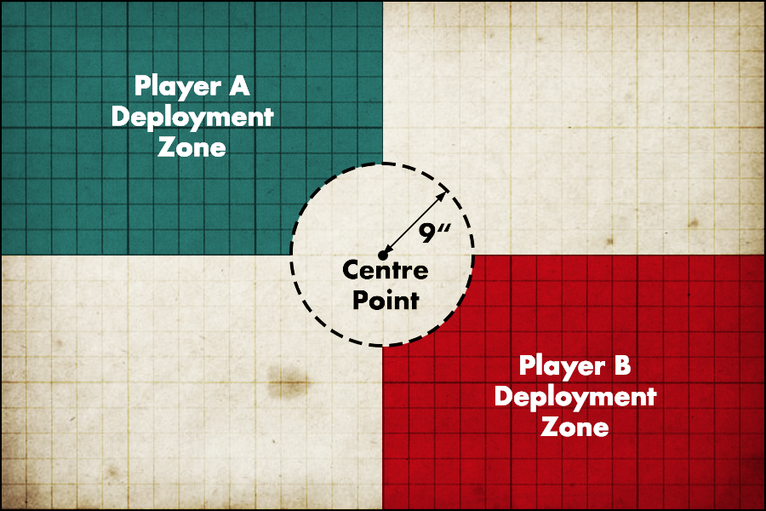

Game length

5 turns

Secondary victory points

* Slay the Command - 1 additional point for killing your opponents strike force leaders
* Linebreaker
* Price of Failure

Night Fighting

Night fights can be chosen to be enforced by the player who lost the initial roll off outlined above.

If a force all forces night fighting e.g. night lords then it happens automatically. Roll as normal for end of night fighting at the end of the turn.

**Mission 2**

**Gathering assets**

The planet is now controlled but the search for the asset of key information is now critical before they fall into the hands of the enemy. However not all assets are what they seem to be, some may not be safe. However others may be more imperative to the war effort than intelligence gathering had originally suggested …

Pre game setup

First players roll off for strategic advantage - the winner decides deployment zone and which force deploys and goes first. The other player decides whether night fighting will be enforced.

The second player can still attempt to seize the initiative on a 6+ plus.

After deployment zones have been decided and before armies are deployed players set up 6 objectives. Starting with the player that won the roll off. All objectives must be deployed outside your own deployment zone, 12 inches apart and 6 inches from a board edge.

Victory Conditions

If a unit is uncontested and controlled by a line unit then score 1 point per objective at the end of the active player’s turn. You can only score objective points in your own turn, not your opponents.

Dawn of war deployment

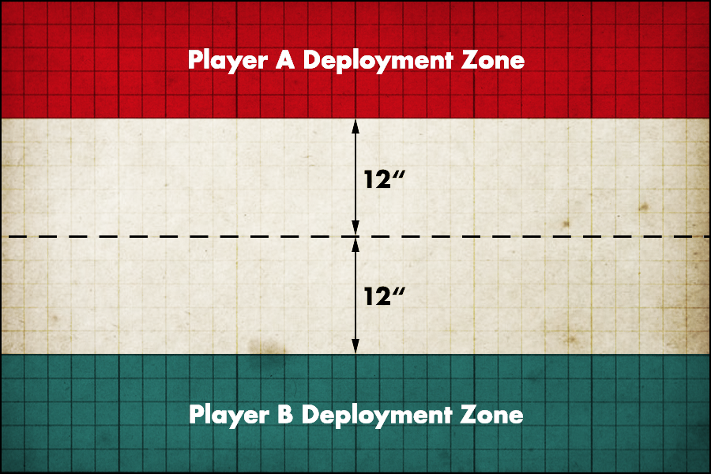

Mysterious objectives table

When a unit moves within 3 inches of an objective or is within 3 inches of an objective at the start of a turn they must roll on the table below to determine the nature of the objective.

We recommend then putting an dice by the objective so you know it's been revealed and the result rolled

| D6 | Result |
| --- | --- |
| 1 | **Sabotaged**- all units within 6 inches of the objective take a d6 strength 5 hit ap - and this objective is worth zero points removed from play after the objective is revealed. |
| 2 | **Nothing of note** - there is no additional effect and the objective is scored as normal. |
| 3 | **Nothing of note** - there is no additional effect and the objective is scored as normal. |
| 4 | **Ammo dump** - the unit controlling this objective re roll 1s to hit when shooting controlling this objective and the objective is not being contested. The objective is scored as normal. This objective has no effect in the combat phase but does affect shooting. |
| 5 | **Scatterfield** - the unit gains a plus 1 to their cover save this stakes to a limit of 4+ cover save. The objective is then scored as normal. |
| 6 | **Grave Wave Generator** - Any unit attempting to charge a unit controlling this objective subtracts 2 from its charge range (to a minimum of 2). This effect is cumulative for other penalties such as charging through terrain. The objective is scored as normal. |

Game length

5 turn game length games

Secondary victory points

* Slay the Command - 1 additional point for killing your opponents strike force leaders
* Linebreaker
* Price of Failure

Night Fighting

Night fighting can be chosen to be enforced by the player who lost the initial roll off outlined above.

If a force enforces night fighting e.g. night lords then it happens automatically. Roll as normal for end of night fighting at the end of the turn.

**Mission 3**

**Withdraw the Relic to turn the war**

The asset has been identified! The intelligence was accurate and a key relic from the Dark Age of the Imperium has been discovered. It is unclear the true value of this relic but it is believed that speed is very much needed to capture the relic to return it back to the fleet so it can be studied. But the enemy also now knows the value of this relic..

Pre game set up

First players roll off for strategic advantage - the winner decides deployment zone and which force deploys and goes first. There is no night fighting in this game as the withdrawal forces of the fleet light up the planet to guide your strike force home to withdrawal of forces.

The second player can still attempt to seize the initiative on a 5+ plus.

Deployment - Vanguard Strike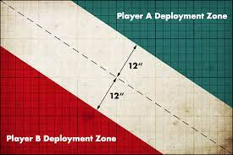

After setting up terrain the players have a single objective marker in the center of the table. If the center of the table is occupied with impassable terrain, place the objective marker as close as possible to the center of the table.

**The objective:**

The objective marker represents essential data intelligence Relic to turn the tide of the war. The Following rules cover seizing, moving and dropping the relic.

**Seizing the relic**: any scoring model with the line subtype can seize the relic by moving into base contact either in the movement phase or during a reaction. From this point the relic is in possession of this relic and can only drop the relic if they are slain and removed from play or falling back.

**Moving with the Relic**: The relic is a very fragile old artifact and therefore moving it is slow. A unit carrying the relic may not run or move more than 6 inches in the movement phase. This unit may still attempt to charge but cannot gain additional movement with the relic as part of a movement reaction.

A unit carrying the relic may not enter a transport with the relic due to the weight of the relic.

**Transfering the relic**: If a model ends its movement in base contact with another friendly scoring model it may transfer the relic to this model. However this model that now holds the relic may not further move that phase due to fear of damaging the relic.

**Dropping the relic:** The controlling player will only drop the relic if the model carrying the relic is killed or falling back. The relic will then drop at the last location of that model. If this position is immediately in base contact with another friendly that is scoring that model is considered to be holding the relic.

Game length

5 turn game length games

Secondary victory points

* Slay the Command - 1 additional point for killing your opponents strike force leaders
* Linebreaker
* Price of Failure

Night Fighting

There is no night fighting in this game and it cannot be forced to be night fighting by any army rules or abilities.